

SHOWING & WORKING HUNTER SHOW

25th May, 22nd June, 3rd August &

14th September

Judges: Ericka Carter & Sandra Samuels

CLASSES ARE £12 PRE-ENTRY PER CLASS

£16 ON THE DAY

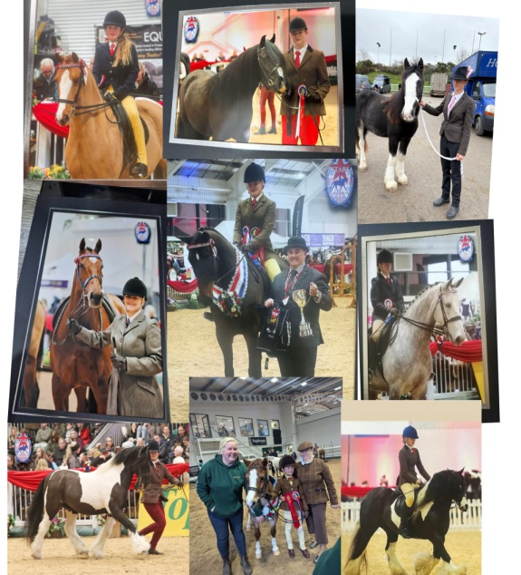

Veteran Horse Society – AREA QUALIFIER 2025

Stars Champion of Champions,

Equifest

Spectators are very welcome & The Arena Café will be open for drinks & refreshments throughout the day – Please contact Natalie for an information – 07718846604

**Ring One: SHOWING (Classes Start at 10.00am)**

**Working Hunter Clear Round 9.00am- £6.00 a round (£1.00 extra for a rosette)**

**Class 1: Jump Height** **30cms** - Open to Ponies 128cms and Under, Riders 10years and under.

**Class 2: Jump Height 50 /55cms**-Open to Ponies & Horses- **Equifest Open Mountain & Moorland Working Hunter Ponies, Equifest Open Working Hunter Ponies/Nursery Stakes**

**Class 3: Jump Height 60/65cms**- Open to Ponies & Horses -**Equifest Open Mountain & Moorland Working Hunter Ponies, Equifest Open Working Hunter Ponies/Nursery Stakes**

**Class 4: Jump Height 70/75cms**- Open to Ponies & Horses **Equifest Open Mountain & Moorland Working Hunter Ponies, Equifest Open Working Hunter Ponies/Nursery Stakes**

**Class 5: Jump Height 80/85cms**- Open to Ponies & Horses

**Class 6: Riding Club Pony/ Horse**- One jump to be included in the Individual Show.

**WORKING HUNTER CHAMPIONSHIP**-1st & 2nd from each class go forward to this Championship

**Class 7: Ridden Veteran Horse or Pony 15 years and** **over** – **Open Ridden Veteran Horse/Pony VHS AREA QUALIFIER-** **VETERAN RIDDEN, COMBINED AGE CLASS (15 years and over). To be run as one class but judged as separate age categories: Diamond Veteran (25 years and over), Veteran (20–24 years) & Pre-Veteran (15–19 years). Open to horses and ponies of any breed and height**

**Class 8: Complete Beginners Showing**- **WALK & TROT ONLY**- Open to Horses or Ponies - Riders any age including Lead Reins, SNAFFLE BRIDLE ONLY

**Class 9: Novice/Green Pony or Horses** -Open to Horses/Ponies. Riders any age. SNAFFLE BRIDLE ONLY - NO CANTERING ON COLLECTIVE ‘GO ROUND’ AND IS OPTIONAL IN THE INDIVIDUAL SHOW.

**Class 10 not to start before 13.00**

**Class 10: Ridden Coloured, Spotted, Palomino, Dun & Roan**- Open to Horses and Ponies. Riders any age, will be split if sufficient entries **Equifest Ridden Piebald & Skewbald**

**Class 11: Ridden Cob** – Hogged or Hairy**. Equifest Open Ridden Cobs, Equifest Open Maxi Cobs**

**Class 12: Ridden Plaited Horses/Ponies including RoR**- Open to Horses/Ponies. Riders any age. **Equifest Open Ridden Show Ponies, Equifest Open Retrained Racehorses, Equifest Open Riding Horses**

**Class 13: Ridden Hunter Type**- Open to Horses & Ponies. Riders any age. **Equifest Open Ridden Show Hunter Ponies. Equifest Open Small Hunters, Equifest Open Ridden Hunters**

**Class 14: Ridden Mountain & Moorland** (Small & Large Breeds)

Riders any age, **Equifest Open Ridden Mountain & Moorland**

**Class 15: Junior / Senior Equitation –** Open to Horses and Ponies. Riders any age – Will be split if sufficient entries.

**Ridden Championship**- 1st & 2nd from each class go forward to this Championship

In all non-restricted age classes, the rider must be a suitable height and weight for the Pony or Horse.

**RING TWO: SHOWING (Classes Start at 10.00am)**

**Class 16: Best Turned Out** –Open to any age rider, horse or pony

**Class 17: Lead Rein Pony**- Open to Ponies 12.2hh and under, Rider 9 years and under Snaffle Bridle Only & Lead Rein must be attached to the Nose Band. No cantering **Equifest Show Pony Lead rein, Equifest Open Show Hunter Ponies**

**Class 18: Mountain & Moorland Lead Rein pony**- Open to Ponies 12.2hh and under, Rider 9 years and under, Snaffle Bridle Only & Lead Rein must be attached to the Nose Band. No cantering. **Equifest Mountain & Moorland Lead Rein**

**Class 19: Lead Rein/ First Ridden Equitation** -Open to Ponies 12.2hh and under, Rider 9 years and under, Snaffle Bridle Only & Lead Rein must be attached to the Nose Band. No cantering.

**Class 20: First Year First Ridden** - Open to Ponies 12.2hh and under, Rider 12 years and Snaffle Bridle Only. No CANTERING ON COLLECTIVE ‘GO ROUND’

**Class 21: First Ridden** - Open to Ponies 12.2hh and under, Rider 12 years and Snaffle Bridle Only. No CANTERING ON COLLECTIVE ‘GO ROUND’ **Equifest Mountain & Moorland First Ridden. Equifest Show Pony First Ridden**

**Class 22: Tiny Tot Handler** – 7 years and under (as of the 1st January 2025) (Children may be assisted by an adult)

**Class 23: Young Handler – 8-12years** (as of the 1st January 2025) (Children may be assisted by an adult)

**MINI CHAMPIONSHIP**-1st & 2nd from each class go forward to this Championship

**Class 24 not to start before 13.00**

**Class 24: Native & Non-Native Young stock:** Yearlings, Two & Three-year-olds - Open to any breed Colt, Filly or Gelding. Stallions MUST be bitted and must be handled by 16 years and over as of the 1st January 2025

**Class 25: Junior Handler - 13years -18years** - (as of the 1st January 2025)

**Class 26: In-Hand Mountain & Moorland** – Small & Large Breeds **Equifest open Mountain & Moorland In Hand**

**Class 27: In-Hand Coloured, Spotted, Palomino, Dun & Roan** - Open to Horses/Ponies, Handlers any age **Equifest in Hand Piebald & Skewbald**

**Class 28: In Hand Plaited Horse/Ponies Including ROR** -Open to Horses/Ponies, Handlers any age. **Equifest Open in hand Riding/Hunter Ponies**

**Class 29: In-Hand Hunter Type** - Open to Horses/ Ponies any age 14.2 and under. **Equifest Open in hand Riding/Hunter Ponies**

**Class 30: In-Hand Cob**- Open to Horses and Ponies, to be shown in Natural or Hogged Handlers any age.

**Class 31: In Hand Veteran Horse or Pony**, 15 years and over-**Open in hand Veteran horse/pony VHS AREA QUALIFIER-** **VETERAN IN HAND, COMBINED AGE CLASS (15 years and over). To be run as one class but judged as separate age categories: Diamond Veteran (25 years and over), Veteran (20–24 years) & Pre-Veteran (15–19 years). Open to horses and ponies of any breed and height**

**Class 32: Open in Hand** - Open to all breeds Horses/ Ponies, Handlers any age.

**IN HAND CHAMPIONSHIP**-1st & 2nd from each class go forward to this Championship

Veteran Horse Society –AREA QUALIFIER 2025.

First round qualifier for the Veteran Horse Society Supreme Final:

VETERAN HORSE OF THE YEAR 2025

Kindly Sponsored by Allen & Page.

Open to members and non-members. All competitors and grooms must adhere to VHS Rules in all circumstances. Failure to do so may result in immediate disqualification.

VHS Regional Final qualification. All competitors placed 1st to 4th in each age category will qualify for the corresponding class at VHS Regional Finals. Members must carry their cards in the ring and have their showing card signed by the judge in the ring as proof of qualification. Non-members will receive a red qualification card which can be exchanged for signed showing card when applying for VHS membership. This MUST be done within 21 days of qualification. It is the competitors’ responsibility to present their Showing card to the judge.

Those wishing to join or renew with the Society will need to apply for this before 1st May each year or a late penalty fee of £15 will be charged.

Regional Finals are open to members only.

All competitors are eligible to enter open classes at the National Veteran Championships, to be held at Arena UK, Lincolnshire on 29th August – 31st August 2025. No qualification or membership necessary. See VHS website for schedule which is available mid-season 2025.

For further information please visit the VHS website www.veteran-horse-society.co.uk or telephone the VHS Show Office on 01239 881300 or 07789 514004.

CLASS 1F VETERAN IN-HAND, COMBINED AGE CLASS (15 years and over). To be run as one class but judged as separate age categories: Diamond Veteran (25 years and over), Veteran (20–24 years) & Pre-Veteran (15–19 years). Open to horses and ponies of any breed and height.

CLASS 2F VETERAN RIDDEN, COMBINED AGE CLASS (15 years and over). To be run as one class but judged as separate age categories: Diamond Veteran (25 years and over), Veteran (20–24 years) & Pre-Veteran (15–19 years). Open to horses and ponies of any breed and height.