
BLUE CROSS AREA 10 HORSE AND PONY CARE COMPETITION
14th April 2025
Approximate start time 9.30am


CARDIFF RIDING SCHOOL PONY CLUB CENTRE
PONTCANNA FIELDS
LLANDAFF
CARDIFF
CF5 2AX
02920383908
Organiser Clare Roberts
07974020089
clroberts@cardiff.gov.uk
Enter online at www.horse-events.co.uk
Entry fee £45 per team
All entries subject to a booking fee
Closing date for entries 31st March 2025
Refreshments available

Class 1 MINI
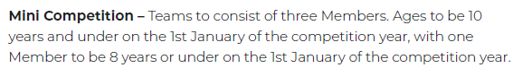
Mini competition will consist of 8 rounds of 8 minutes
Class 2 JUNIOR
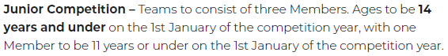
Class 3 SENIOR
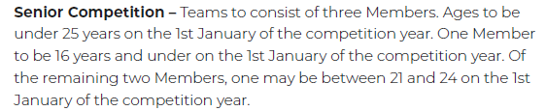
Junior and Senior competition will consist of 8 rounds of 10 minutes
All information can be found on the Pony Club website
2025-Rulebook-Horsemanship-221224.pdf
Please see dress code in rule book.
All ages taken on 1st January 2025
All clubs entering please provide a suitable assessor for the day. Please email clroberts@cardiff.gov.uk with their details.
