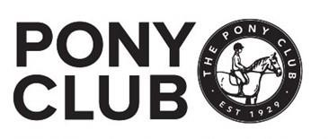
Pony Club Area 12 Dressage Show
Sunday 29th June 2025
To be held at: Berkshire College of Agriculture
Hall Place
Burchetts Green
Maidenhead
Berkshire
SL6 6QR
Organising branch Hertfordshire Hunt

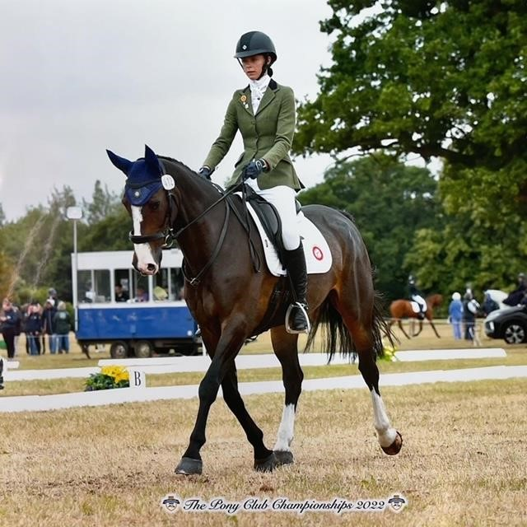

Secretary & contact on the day: Zoe Vaughan 07739844326
For entry information contact: info@horse-events.co.uk 07962 251 696 (before 7pm)
Entries close: Tuesday 17nd June 2025

Late entries will NOT be accepted.
CLASSES

CLASS 1: PRIX CAPRILLI

TEST: PRIX CAPRILLI Rider Test 8 (updated 25)
(can be commanded in line with Area 12 Prix Caprilli Rules

CLASS 2: PC70

TEST: Pony Club Preliminary PC70 Dressage Test 2022

(can be commanded in line with Area Dressage Rules 2025)

CLASS 3: PC80

TEST: Pony Club Grassroots PC80 Dressage Test 2018

(can be commanded in line with Area Dressage Rules 2025)

Classes 2&3 are qualifiers for the Eastern Region Grassroots Championship 2025 on 30^{th-}31st August Eastern Regional Championships, Aston le Walls and the Area 12 Championships.

CLASS 4: Novice

TEST: Pony Club Novice Dressage 2020

CLASS 5: INTERMEDIATE

TEST: Pony Club Intermediate Dressage 2024

CLASS 6: OPEN

Test: Pony Club Open Dressage Test 2020

Classes 4,5 & 6 are qualifiers for the JCB Pony Club National Championships 2025 on 8^{th-}16th August 2025 Offchurch Bury, Warwickshire

Teams & Individuals- for eligibility see PC Dressage rulebook 2025 Part 1 point 4

Please note that as per Rule 49 page 38 classes 4 to 6 (inclusive) may not be commanded in line with Area Dressage rules 2025.

ENTRIES

Only open to Area 12 Pony Club branch and centre members.

Entries should be made via your Dressage Team Manager and with the approval of the branch District Commissioner of your pony club branch.

Fees per class

Class 1 £20 (inc paramedic fee) + £1.45 Booking Fee
Classes 2-6 £25 (inc paramedic fee) + £1.45 Booking Fee

Booking fees are payable direct to horse-events.co.uk when placing your entry and are nonrefundable and on a per class basis.

If you would like to edit your horse or rider details before the closing date of the event please log in to your Horse Events account and edit your booking under the ‘MY BOOKING’ tab.

If you would like to change the class please email info@horse-events.co.uk and if there is space available they will do this for you.

For all changes of horse and rider substitutions after the closing date there is a £5 charge please fill out the following form online at https://www.horse-events.co.uk/rider-horse-substitutions-form/

Team entries: Please indicate team name when entering. There is no separate team entry fee We will endeavour to create mixed teams with individuals where possible.

AGES
Ages as at 1st January 2025 (indicate on entry where applicable)

Rosettes & Prizes
Class 1 Individuals to 10th place for all sections
Classes 2-6 Individuals to 6th place all classes/sections Teams to 6th place

Additional prizes may also be presented at the presentation ceremony following each class. Please encourage all competitors to attend prize giving.

DRESSAGE INSTRUCTIONS

Times will be available from Wednesday 25th June 2025 on www.ponyclubresults.co.uk

RESPONSIBLILY FOR CORRECT TACK AND DRESS remains the responsibility of the member and DC.

REASONABLE ADJUSTMENT The Pony Club is committed to ensuring that, wherever possible, members are able to access all aspects of the Branch and Centre activities we offer.
Adjustments are any reasonable actions that help to reduce the effect of a disability or difficulty.
Any requests for Reasonable Adjustment must be made by Friday, 20th June, to: Zoe Vaughan (HHPC DC) 07739 844326 Hertfordshire@pcuk.org

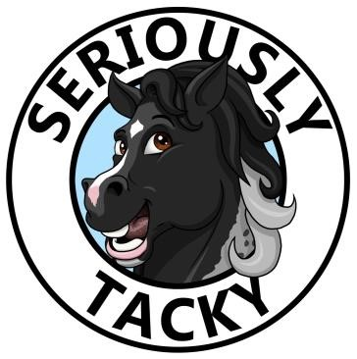
Will be on site for last minute essentials on the day

Conditions of Entry

- Legal Liability: Save for the death or personal injury caused by the negligence of the organisers, or anyone for whom they are in law responsible, neither the organisers of this event or The Pony Club nor any agent, employee or representative of these bodies, nor the landlord or his tenant, accepts any liability for any accident, loss, damage, injury or illness to horses, owners, riders, spectators, land, cars, their contents and accessories, or any other person or property whatsoever. Entries are only accepted on this basis.

- Health & Safety: Organisers of this event have taken the reasonable precautions to ensure the health and safety of everyone present. For these measures to be effective, everyone must take all reasonable precautions to avoid and prevent accidents occurring and must obey the instructions of the organisers and all the officials and stewards

- Reasonable Adjustment: Any requests for Reasonable Adjustment must be made by the closing date. https://pcuk.org/officials/equality-diversity/reasonable-adjustment/

- Rules: The event will be run under Pony Club Dressage Rules 2025 and it is the responsibility of the competitors to make sure that they understand and adhere to the rules.

- Vaccination: The event venue stipulates all horses/ponies entering the event site must comply with 2025 Pony Club vaccination rules - passports must accompany all horses/ponies and spot checks may be undertaken

- Hat- Tagging: Please ensure that the riding hat is tagged in line with the pony club rules (pink tags). Yellow hat tags are required if wearing spurs.

- Reservation of Rights: The organisers reserve the right to alter, amend or cancel any class/ amalgamate sections where there are insufficient entries or split classes if oversubscribed and reserve the right to disqualify anyone for misuse of the whip or spurs, dangerous riding or any horse/pony in poor lame condition, and to refuse any entry for any reason at their sole discretion.

- Withdrawal and abandonment: The event will follow 2025 withdrawal and abandonment criteria (Rule 7 and 8) regarding refunds: If a member, branch or centre withdraws a team or individual prior to the closing date for a competition, a full refund of entry will be made, less an administration charge of £5. Withdrawals after the closing date for a competition will not be refunded. In the event of a competition being abandoned, for whatever reason, a refund of 50% of the entry fee will be given.

- Tests: Copies of tests can be downloaded from the pony club website.

- Time & Results: We will use Pony Club Results for times and results.

- Lunging: No Lunging will be allowed on the day.

Photographer is Charlotte Bury Photography -www.charlotteburyphotography.co.uk



Other than parents &guardians photographing their own children, no other photographers will be permitted on site.

Photographic rights: Participants and their parents/guardians give permission for any photographs taken by the designated photographer at the event to be developed for sale and published on the internet only for the purposes of resale or for Herts Hunt Branch of the Pony Club publicity purposes.

With many thanks to our sponsors, prize donators and stands
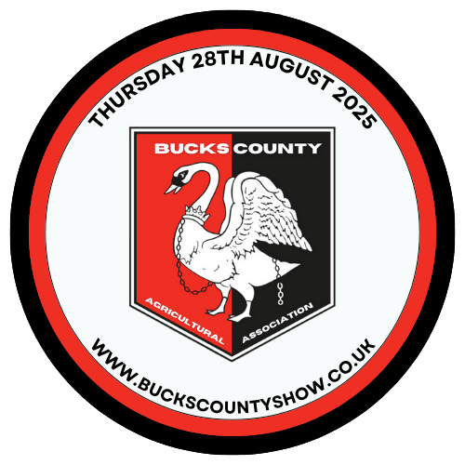


Seriously Tacky
Cam Floral Design
Amelia Clow Interiors
Chiltern Tiles, Pitstone
Old Dairy Garage, Tring
Master Driver Car Sales, Aylesbury
Bucks County Show
MK Equestrian

The vet on call on will be Scott Dunn’s Equine Clinic

It just remains to say looking forward to seeing you all on the day!

CAM FLORAL DESIGN  Supplier of our beautiful arena flowers | 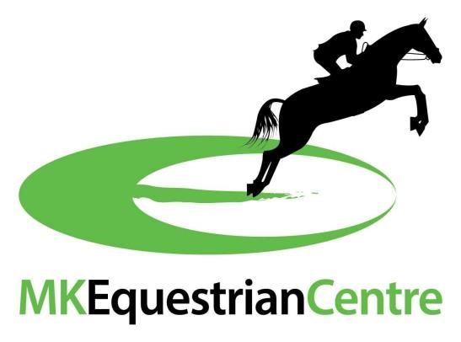
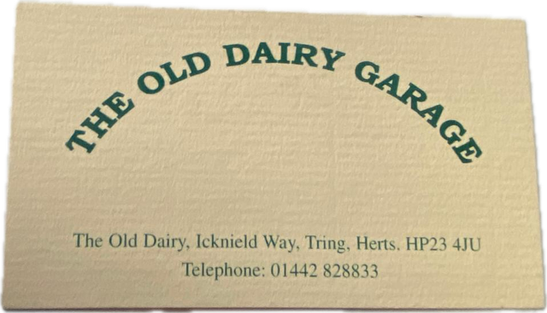 | 

