### MOSS END Horse and dog Show

|  |  |
| --- | --- |
| Sunday 23 June 2024  Moss End Farm,  Warfield , near Bracknell RG42 6EJ  Website: [www.mossendshows.com](http://www.mossendshows.com)  **ENTER ONLINE AT** [www.horse-events.co.uk](http://www.horse-events.co.uk) Entries secretary [info@horse-events.co.uk](mailto:info@horse-events.co.uk) or call 07962 251696 not after 7pm Show Organiser: Mrs M-A Hodson MBE, Spring Lanes House, Holly Spring Lane, Bracknell, Berkshire RG12 2JL Tel: 01344 483347 email: [mah@mossendshows.com](mailto:%20mah@mossendshows.com%20) | A silhouette of people riding horses  Description automatically generatedThis show will benefit  the Warfield RDA Group,  Charity No. 1074001 Two or three tier rosettes,  a trophy and prize money  awarded in every Horse class  except for Clear Round and Dog Classes CHAPS UK AFFILIATION NUMBER 24-034 AHS NUMBER for 2024 is 110623. |
| Exciting news: we now feature a Dog Show on Ring 1, from 1:30pm. Bring your dogs to share a great day out! | |

**Special thanks to:**   
SUEZ Recycling and Recovery UK Ltd Mrs S Pidgley  
David Lochman Course builder  
Arena Party: Windsor Lions  
Photographer Laurence J Power [laurence@polopower.co.uk](mailto:laurence@polopower.co.uk)  
First Aid: Richard Kirkham Vet-on call: Scott Dunn  
Catering by  Natalie  
Sweets on sale by Sweet Tiger  
Millwheel Tack Shop

**We are very grateful to the Show’s sponsors:**

Gilly and Terry Norris Anne and Stephen Messer   
Jane Rimmer HIVIZ–Marketing Kristina Malmstrom  
Berkshire Riding Centre Ltd, Winkfield Oaktree Nursery  
Inter Surgical Respiratory Systems    
Cranbourne Dog Training School (www.cdts.co.uk)

**Invited judges:**

Gail Ward Ring 1 DOG SHOW

David Lochman- Ring 2 Clear Round Jumping

Jo Tuccio - Classes 7, 8 and 17

Claire Goodwin- Classes 9, 12 and 16

Caroline Reid Classes 11, 13

Pauline Levi-Tilley- Classes 22A/B/C

Sharon Edwards Classes 14, 15, 24A/B

Andrew van Oostrum MDH- Classes 18, 19

Sara Egan - Classes 20A/B, 21A-D, 23A/B

CLASS 24- Learn to Show in Hand

CLASS 24 is for competitors who would like to show their horses/ ponies in hand but are unsure of the correct procedure. For this class, please state which section you are entering. Competitors in this class may show their ponies to the judges before taking part in the Tack & Turnout classes. The judge will be advised of this situation. THIS IS A GOOD CLASS FOR ANYONE WANTING TO SHOW THEIR HORSE/PONY IN HAND – TRY CLASS 7 AS WELL!  
  
If you have any queries regarding online entries, please contact Horse Events info@horse-events.co..uk

CONDITIONS OF ENTRY

1 **Entries close Wednesday 19 June 2024. Entries will be restricted in all classes, so enter in good time to be sure of acceptance**.

2 Late entries will be accepted on the day at £3.00 extra for all classes, if the class is not already filled.

3 Refunds will be made on receipt of S.A.E. with vet or doctor’s certificate less £6.00 administration fee. **OTHERWISE, REFUNDS ARE NOT AVAIL-ABLE FOR RETURN OF FEES IF THE CLASS TAKES PLACE.**

4 Hard hats must be worn when mounted.

5 The judge's decision is final.

6 Horses or ponies must be the minimum age of four years.

7 The Organisers accept no liability for any damage to competitors, spectators, officials or property. This is a condition of entry.

8 All challenge trophies must be returned clean by the beginning of June 2025.

9 We reserve the right to cancel classes if insufficient entries are received by the closing date, and to withhold prize money where classes are inadequately filled.

10 All rings will be marked and the classes taking part in each ring will also be marked. Competitors must be responsible for being near the ring, prior to their class starting. **REFUNDS WILL NOT BE MADE IF YOU DO NOT SHOW UP ON TIME – SEE ALSO RULE 3 ABOVE.**

11 All showing classes will take place in Ring 3, 4 or 5. We will try and place them in the order given in the schedule, but reserve the right to move them if many competitors are being kept waiting. We will not start any class if sufficient riders are already taking part in a similar class.

12 This show is affiliated to The Coloured Horse & Pony Society (UK). See under Class 22 for rules.

13 All entries in the Arabian/Anglo/part-bred Arab classes must be registered in the appropriate stud-book/register of the Arab Horse Society, by the closing date of entry. **Please send photocopies of registration certificates with the entries.** Please go to **www.arabhorsesociety.com** and click "Shows and Events" for the rules.

14 Correct riding clothes must be worn in all jumping and showing classes.

15 All stallions must wear stallion ID discs in the ring, without exception.

|  |  |  |  |  |  |  |
| --- | --- | --- | --- | --- | --- | --- |
| **This show is a qualifier for The Sunshine Tour Championships** held at The All England Showground, Hickstead from Thursday 12– Sunday 15 September 2024.  The Championships are for unaffiliated and amateur competitors in Show Jumping from Lead Rein to 1.05m; Showing for lead rein, in-hand, ridden, working hunter, veterans, plus many more.  Qualification: 1st – 3rd place. Qualification does not pass down the line.  Visit [**www.sunshinetour.co.uk**](http://www.sunshinetour.co.uk/) for more information, to register and submit evidence of qualification. Registration must be completed within 1 month of qualification (sooner for late July shows). Restrictions apply to horse and competitor previous winnings and amateur status; please check the website [www.sunshinetour.co.uk](http://www.sunshinetour.co.uk/) for Terms & Conditions.  RING 1 (starting at 1:30pm)  A Dog Show run by Cranbourne Dog Training School  All Dog entries will be taken on the day -NO ENTRIES ONLINE OR BEFORE THE DAY!! | | | | | | |
| Class 1 | | Best Rescue Dog | | | £2.50 | |
| Class 2 | | Dog in Best Condition | | | £2.50 | |
| Class 3 | | Best Veteran over 9 Years | | | £2.50 | |
| Class 4 | | **Best Puppy Under 9 Months** | | | £2.50 | |
| Class 5 | | Best Pure Bred | | | £2.50 | |
| Class 6 | | Dog Most Like Its Owner | | | £2.50 | |
| RING 2 (starting at 9am) | | | | | | |
| Clear Round Jumping 9am - 12 noon, and then from 2-4pm Entries on the day. Course raised during the morning | | | | | £3.00 | |
| RING 3 (starting at 9am) | | | | | | |
| Class 7 A and B | Tack and Turnout (grass kept and stable kept). This class is divided  into two sections to run at the same time. Section A is grass-kept; Section B is  stable kept. Please state on entry form in which of A or B you are competing. | | | | £10.00 | |
| A bag of feed will be given to the winner of each section, kindly donated by Woodcray  Feeds, Wokingham. Prize money for these classes kindly donated by Steve Kattau. | | | | | | |
| Class 8 | Leading Rein – CHAPS QUALIFIER (bring cards) | | | | £10.00 | |
| Ponies not to exceed 12.2hh; to be shown in snaffle bridles. Riders 10 years and under.  *Kindly sponsored by the* **Barlow Family***. A trophy will be awarded.* | | | | | | |
| Class 9 | Child's First Pony – CHAPS QUALIFIER (bring cards) | | | | £10.00 | |
| Ponies not to exceed 13.2hh; to be shown in snaffle bridles. Riders 12 years and under.  A trophy will be awarded, and prize money kindly sponsored by **Dolly Langton**. | | | | | | |
| Class 10 | Ridden Veteran Horse/Pony. This class will divide A: age 15-20 and B: 20  & over. CHAPS QUALIFIER (bring cards) | | | | £10.00 | |
| **Aged 15 years and over.** Please include age of horse on Entry form. Two trophies and prize money will be awarded, kindly sponsored by **Faith Brotherson**. | | | | | | |
| Class 11 This class will start at 2pm approx-imately | Arabs in Hand (any age) - for the Flet Memorial Trophy - see Conditions of Entry  Section A Pure bred  Section B Part bred or Anglo Arab - prize money kindly given by Winkfield Manor Farm  **Then a championship. See conditions of entry.** These sections will combine if there are insufficient entries. *The pure-bred prize-money and trophy for* ***Class 11****, and the championship rosettes for* ***Classes 11******and 13*** *are sponsored by* **SUEZ Recycling & Recovery UK Ltd.** A special rosette will be awarded to the best 1 year old in this class. | | | | £10.00 |
| Class 12 | Riding Club Horse  For horses exceeding 14.2hh. Will be asked to show suitability for all Riding Club  activities. Will not have to jump. *Kindly sponsored* by **Mary-Lou Bruce***. A trophy  will be awarded.* | | | | £10.00 |
| Class 13 | Ridden Arabs (4 years and over) - see Conditions of Entry, Item 13.  Section A Pure bred *Trophies awarded to the champion*  Section B Part bred or Anglo Arab *and reserve champion*  Prize money kindly sponsored by **Gwen Jenkins** | | | | £10.00 |
| RING 4 (starting at 9:30am approx.) | | | | | | | |
| Class 14 | Pony Club Pony. Horse/pony 15hh and under. Riders to be under 25 on 1/1/2022.  The class will be judged on suitability for all Pony Club activities. You may be  required to jump. Prize money and trophy kindly sponsored by Eileen Douglas,  The Tack Shop, Wokingham. | | | £10.00 | | | |
| Class 15 | Family Pony/horse. Horse/pony 13.2hh up to 15.2hh. To be ridden by a child or  an adult. To be shown in a snaffle bridle. *Prize money kindly sponsored by* Geraldine and Mike Lindquist. | | | £10.00 | | | |
| Class 16 | Horse or pony most suited to its rider. Competitors will be required to give a small show. *Kindly sponsored by* Brian Murphy*.* | | | £10.00 | | | |
| Class 17 | Best Junior Handler 12 years and under. Pony of any type shown in hand. *Prize money kindly sponsored by the* Diana Devine. | | | £10.00 | | | |
| Class 18 | | | Working Hunter Pony Starting at approximately 2pm  Ponies up to 15hh. To jump a course of natural fences up to 2' 6" (75cm).  A trophy will be awarded. Kindly sponsored by **Jill and Philip Glennerster** | £10.00 | | | |
| Class 19 | | | **Working Hunter** For Horses exceeding 15hh. To jump a course of natural fences up to  approx. 2' 9" (85cm). A trophy will be awarded. Prize-money kindly given by  Emma and Tony Clark. | £10.00 | | | |
| Class 18 & 19 winners qualify for a voucher for a free days Hunting with the Berks and Bucks Drag Hounds. | | | | | | | |
| RING 5 (starting at 9:30am) | | | | | | | |
| Class 20 | | | Youngstock (in hand) Open to horses or ponies of any breed or sex.  Section A 1 and 2 year olds Section B 3 year olds  Trophies will be awarded. Prize money for this class has been kindly sponsored by **Virginia Bignal** and by **Chapmans of Sunninghill** - traditional ironmongers and  suppliers of all kinds of goods. **See website:** [**www.chapmansironmongers.co.uk**](http://www.chapmansironmongers.co.uk/)**.** | £10.00 | | | |
| Class 21 | | | Mountain and Moorland (in hand). Please state breed, section and leader on entry form  Section A Registered ponies (Large Breeds)  Section B Registered ponies (Small Breeds)  Section C Unregistered ponies (Large Breeds)  Section D Unregistered ponies (Small Breeds)  Trophies will be awarded. Prize money presented by **Christopher and** **Harry Fisher**. | £10.00 | | | |
| Class 22 | | | Coloured Horses/Ponies and Youngstock - all sections will run as separate classes Open CHAPS (UK) Qualifiers. Please note CHAPS rules overleaf  Section A CHAPS (UK) Open Youngstock Qualifier 1 - 3 year-olds - no foals  Section B CHAPS (UK) Open In Hand qualifier, any height, any type  Section C CHAPS (UK) Open Ridden Qualifier, any height, any type  This class will divide if sufficient entries are received. Please see rules below.  Prize-money for this class has been presented by **Anne and Michael Shattock**. | £10.00 | | | |
| This show is affiliated to the Coloured Horse and Pony Society (UK) affiliation number 24-034. Both owner and rider/exhibitor need not be a member of CHAPS(UK) nor must the horse or pony be registered with CHAPS(UK) to compete.  However, in order to qualify, both owner and rider/exhibitor need to be a current showing member and present their valid qualifier card  IN THE RING for signing by the judge. Members to apply in writing to CHAPS(UK) for appropriate qualifier card. The CHAPS(UK) Championship Show will be held from 15-17 August 2024 at ARENA UK, Allington Ln, Grantham NG32 2EF The following classes are CHAPS(UK) Qualifiers: 8,9,10, 22A/B/C. For full rulings and information on competition/qualification, please refer to the CHAPS(UK) MEMBERS’ HANDBOOK; or visit [www.chapsuk.com](http://www.chapsuk.com) for rulings. All stallions 4 years old and over entering these classes must be graded with CHAPS(UK). All stallions must wear stallion ID discs in the ring ‑ without exception. | | | | | | | |
| Class 23 | | | Mountain and Moorland (Ridden) - please state breed and section on  entry form Open to registered or un-registered breeds:  Section A Large Breeds Section B Small Breeds  Trophies will be awarded. This Class is sponsored by Richard O'Donovan and  Gresswell Gardens (see [www.gressgardens.co.uk](http://www.gressgardens.co.uk) – garden services and tree surgeons). | £10.00 | | | |

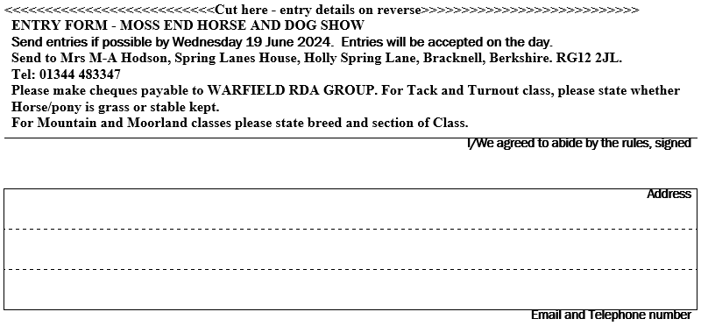

|  |  |  |
| --- | --- | --- |
| RING 6 (starting at 9am) | | |
| Class 24 | Learn How To Show In Hand Correctly! See Front Page for details for this Class.  Trophy, prize money and rosettes will be presented to the best handlers. All age groups welcomed. Section A for children 13 years and under. Section B for 14 years and over. Please state which section when entering. Competitors in this class may show their ponies to the judges and take part in the Tack & Turnout Class.  Prize money has been given by the **Glennifers Stables**. A salver will be presented to the winners of each Section, in memory of Caroline Stephens, the founder of this class. | £10.00 |
| Class 25 | Handy Pony Class (10:30am - 12 noon)  Entries at the ringside. A trophy will be awarded to the fastest clear round. | £2.00 |

|  |  |
| --- | --- |
| GYMKHANA EVENTS (STARTING AT APPROX. 2.15 PM IN RING 6)  Entries on the day at the Ringside. **£3.00** per class | |
| 9 years and under (may be led) | |
| Class 26 | Ride and Run |
| Class 27 | Walk and Trot |
| Class 28 | Round the World |
| Class 29 | Bending |
| 10-12 years and over | |
| Class 30 | Bending |
| Class 31 | Old Socks |
| Class 32 | Mug race |
| 13 years and over | |
| Class 33 | Bending |
| Class 34 | Old Socks |
| Class 35 | Mug Race |

**5 March 2024**

         Reaching the Show

The Moss End Horse and Dog Show  
is on the A3095 road from Bracknell to  
Maidenhead, and is near the Moss End  
Garden Village. The entrance to the   
show is off the main road, and so please take particular care as you drive in!

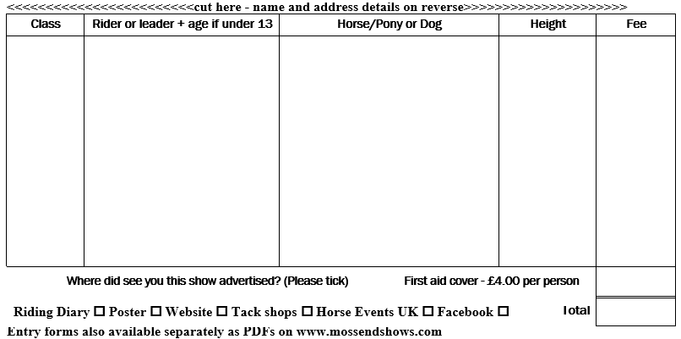PLEASE DO NOT CALL AN AMBULANCE WITHOUT FIRST SPEAKING TO OUR MEDICAL TEAM!!